Marks : 8
Total_Mark column is not calculated
Comment and Insight missing

library(readxl)
library(dplyr)
library(ggplot2)
library(cowplot)

students = read_excel("D:/SIBM Bengaluru - Studies/Programming for Data Sciences/Assignment - 1/StudentsPerformance.xlsx")

View(students)
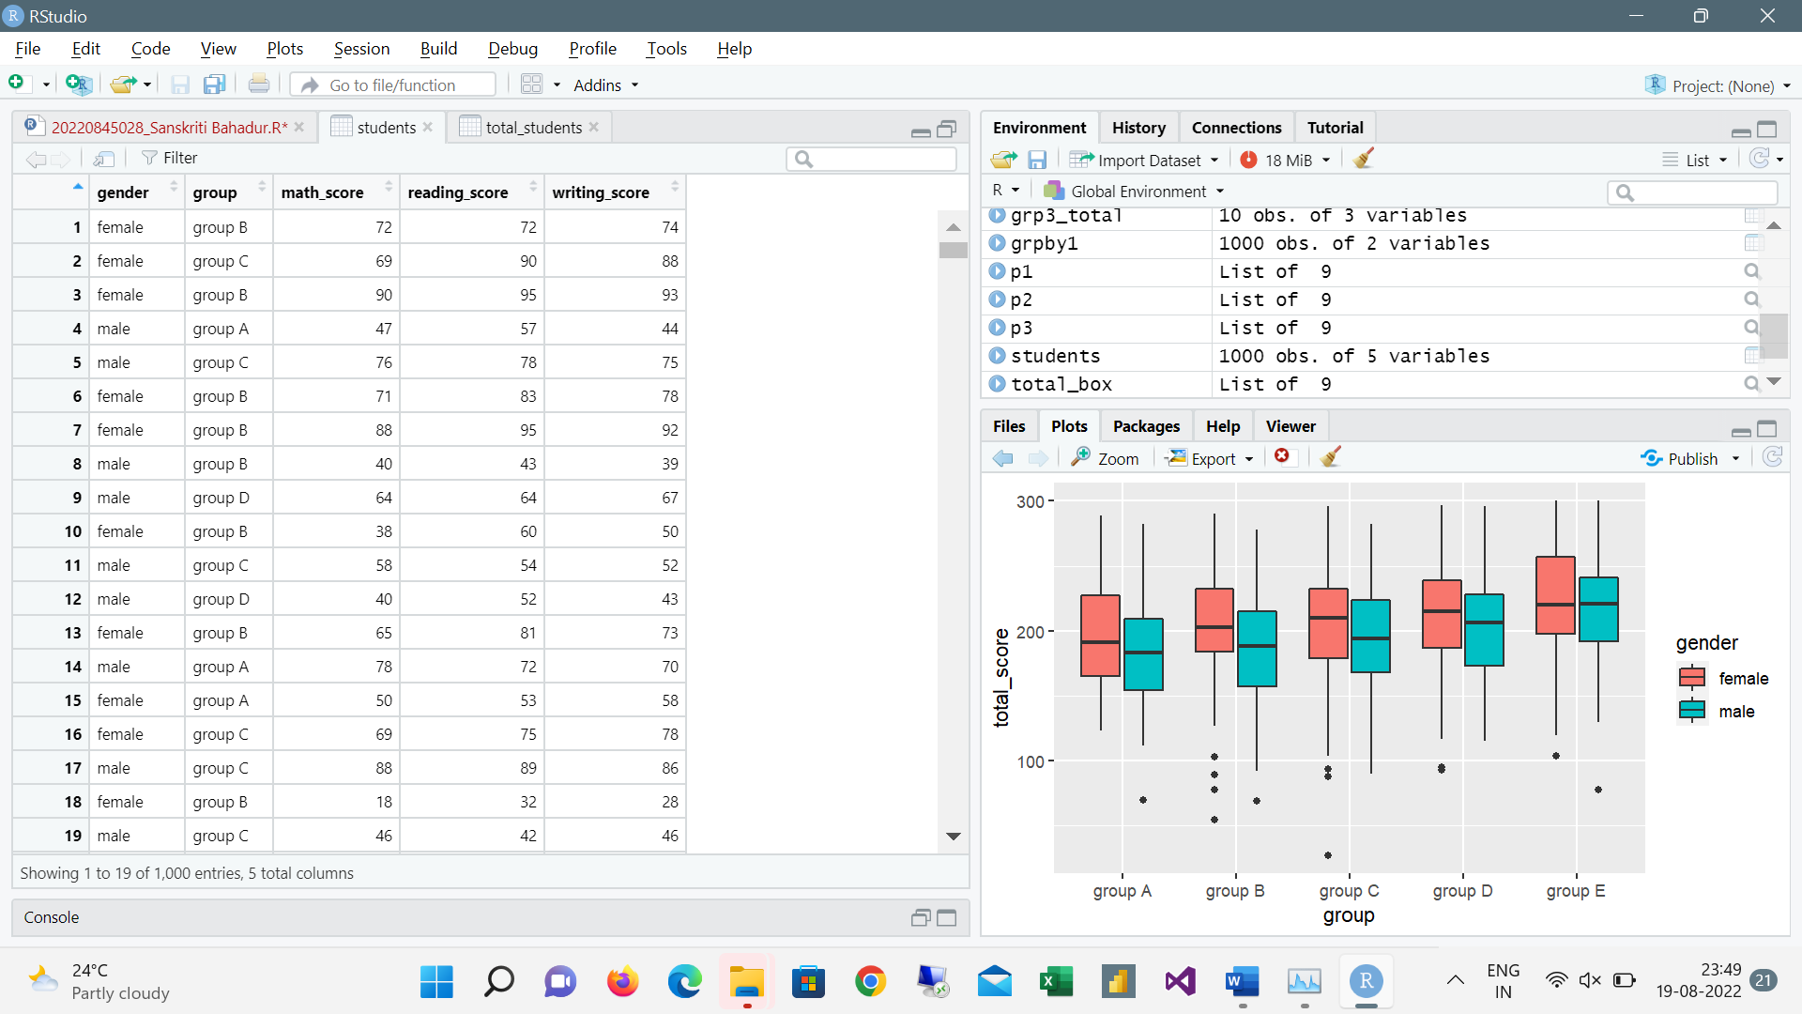
head(students)
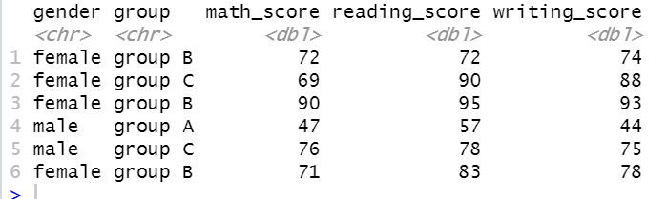
tail(students)
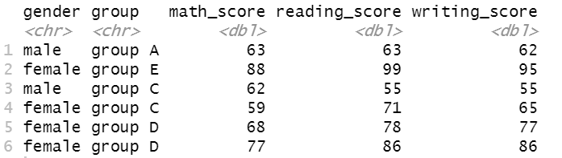
nrow(students)
Ans: 1000
summary(students)
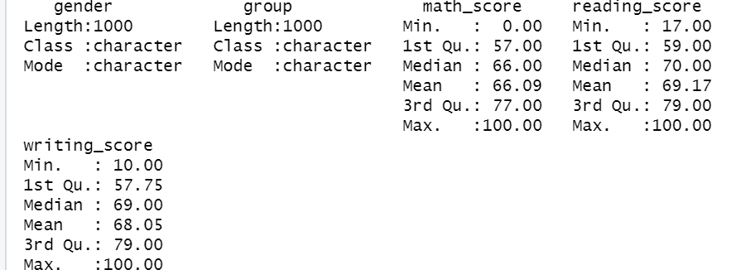
str(students)
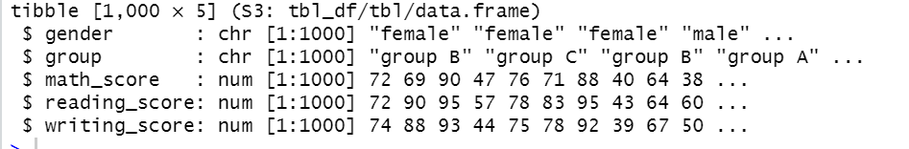
print(students)

grp_count = students %>% count(group)
grp_count

summarise(students,med = median(math_score))
Ans: Med 66

summarise(students,med = median(reading_score))
Ans: Med 70
summarise(students, med = median (writing_score))
Ans: Med 69

Group_A_Count = students %>% count(group)
Group_A_Count

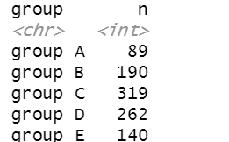

students %>% filter(is.na(group))
students %>% filter(is.na(gender))
students %>% filter(gender=='male' & group =='group B')
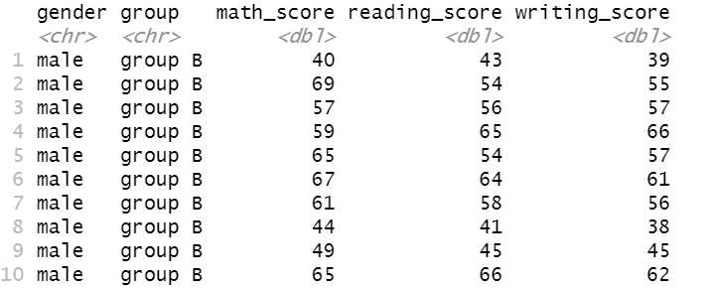
students %>% filter(group == 'group B' & math_score == 90)
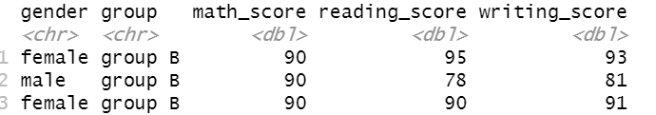

students= mutate(students,average_score = round((math_score+reading_score+writing_score)/3))
students$average_score
head(students)
View(average_score)
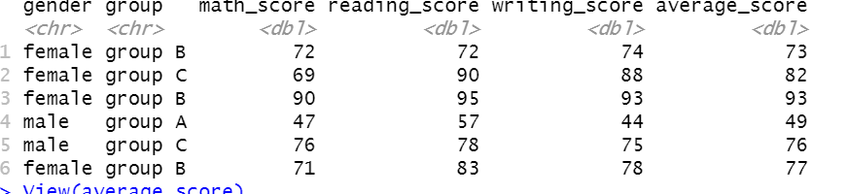

#Analysing the performance of one group
grp_math_score = students %>% group_by(group) %>%
summarise(sum_math_score = sum(math_score))
grp_math_score

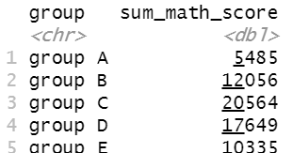

grp_reading_score = students %>% group_by(group) %>%
summarise(sum_reading_score = sum(reading_score))
grp_reading_score

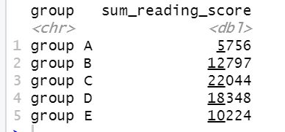
grp_writing_score = students %>% group_by(group) %>%
summarise(sum_writing_score = sum(writing_score))
grp_writing_score

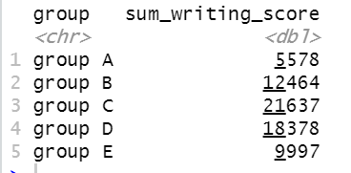

agg_math_score = aggregate(students$math_score, list(students$group), FUN=mean)
colnames(agg_math_score) <- c('group','avg_math_score')
agg_math_score

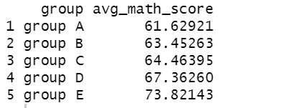

agg_reading_score = aggregate(students$reading_score, list(students$group), FUN=mean)
colnames(agg_reading_score) <- c('group','avg_reading_score')
agg_reading_score
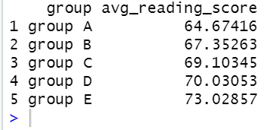

agg_writing_score = aggregate(students$writing_score, list(students$group), FUN=mean)
colnames(agg_writing_score) <- c('group','avg_writing_score')
agg_writing_score
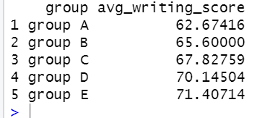

dev.off(dev.list()["RStudioGD"])

p1 = ggplot(grp_math_score, aes(x=group, y=sum_math_score,fill=group)) + geom_bar(stat="identity") +
labs(x="Groups", y="Total_Math_Score")
p1

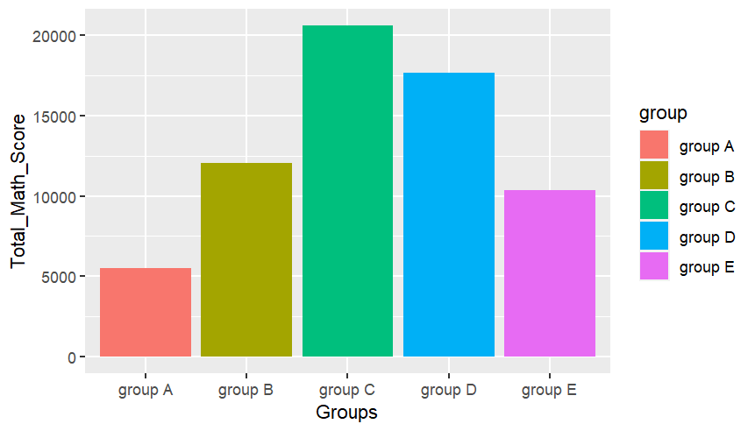
p2 = ggplot(grp_reading_score, aes(x=group, y=sum_reading_score,fill=group)) + geom_bar(stat="identity") +
labs(x="Groups", y="Total_Reading_Score")
p2

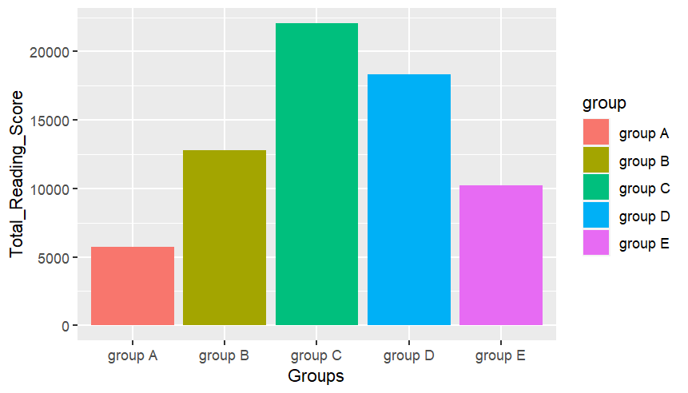
p3 = ggplot(grp_writing_score, aes(x=group, y=sum_writing_score,fill=group)) + geom_bar(stat="identity") +
labs(x="Groups", y="Total_Writing_Score")
p3
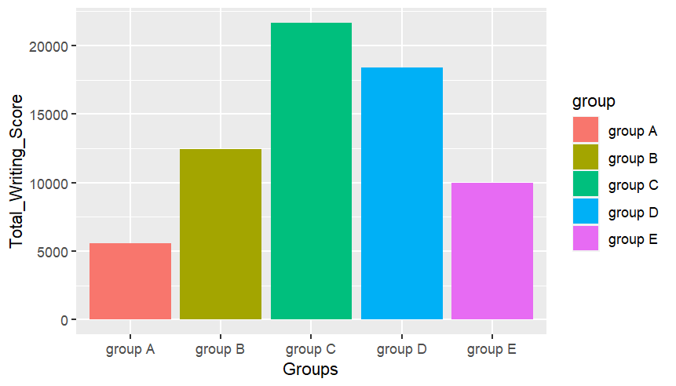
plot_grid(p1,p2,p3,labels="AUTO")

# Analysing gender performance in math for each group

grp2_sum = students %>% group_by(group,gender) %>%
summarise(sum_math = sum(math_score))
grp2_sum

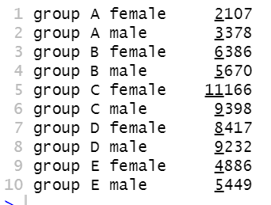

grp2_avg = students %>% group_by(group,gender) %>%
summarise(avg_math = mean(math_score))
grp2_avg

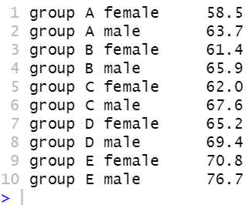

ggplot(grp2_sum,(aes(x=group,y=sum_math,fill=gender))) +
geom_bar(stat = "identity",position = "dodge")

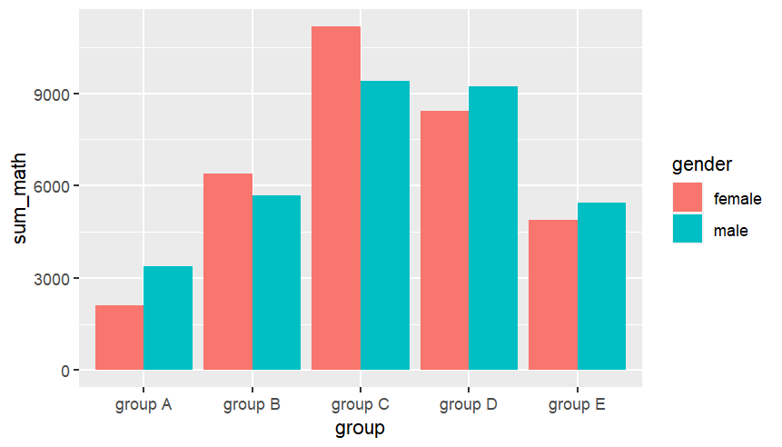

ggplot(grp2_avg,(aes(x=group,y=avg_math,fill=gender))) +
geom_bar(stat = "identity",position = "dodge")

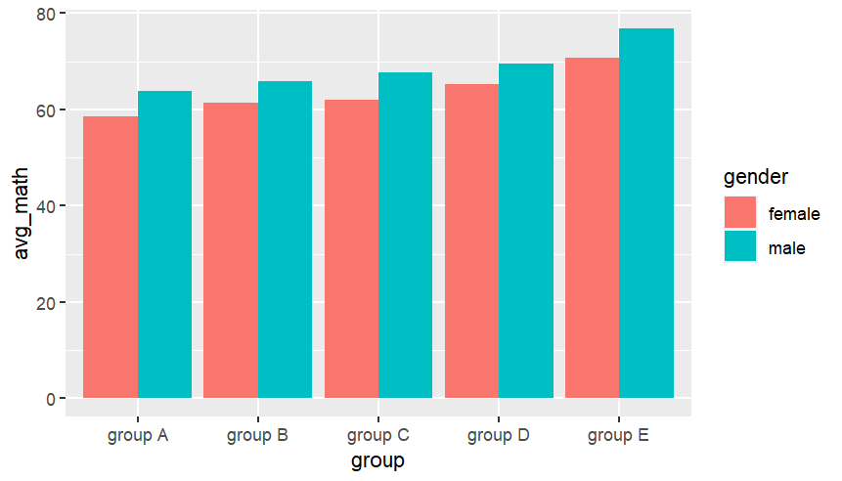

#Add a new column "Total Mark" and analyse the group performance with respect to total marks

total_students = mutate(students,total_score = (math_score+reading_score+writing_score))
total_students$total_score
head(total_students)
View(total_score)
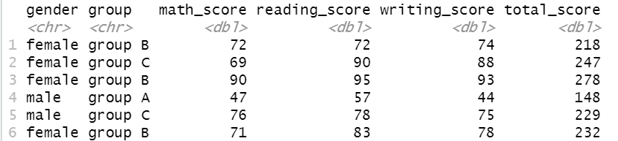
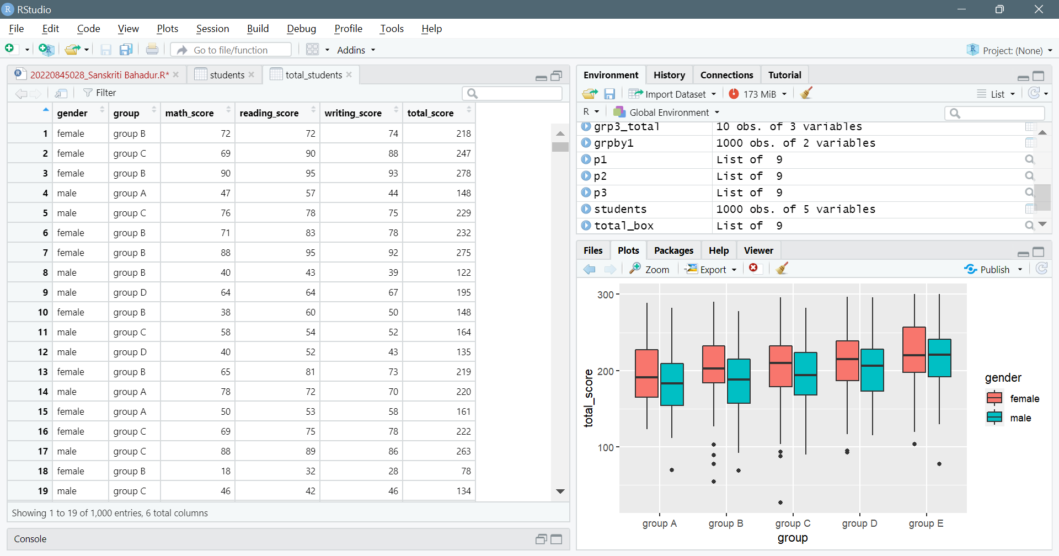

grp3_total = total_students %>% group_by(group,gender) %>%
summarise(sum_total = sum(total_score))
grp3_total
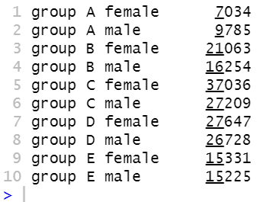

ggplot(grp3_total,(aes(x=group,y=sum_total,fill=gender))) +
geom_bar(stat = "identity",position = "dodge")
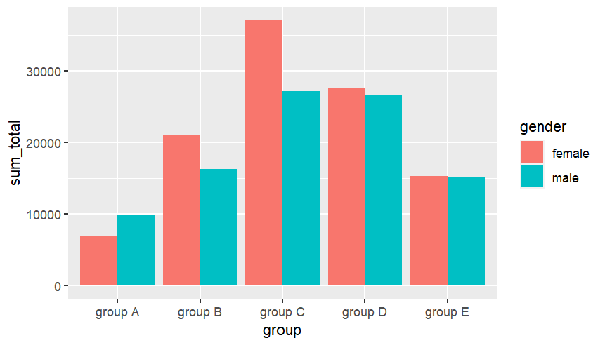

total_box=ggplot(total_students, mapping=aes(x=group, y=total_score))+geom_boxplot()
total_box
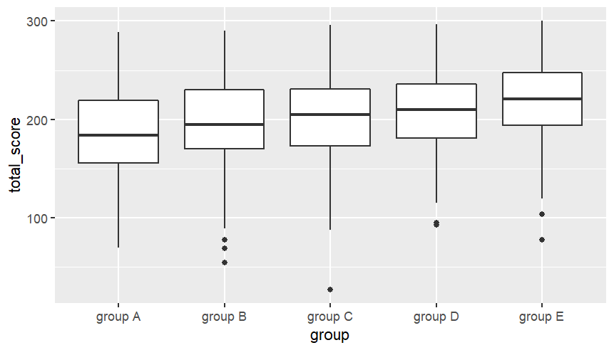
Box Plot to find minimum, maximum, median, Q1 and Q3 value of a group
total_box=gg
total_box=ggplot(total_students, mapping=aes(x=group, y=total_score, fill=gender))+geom_boxplot()
total_box
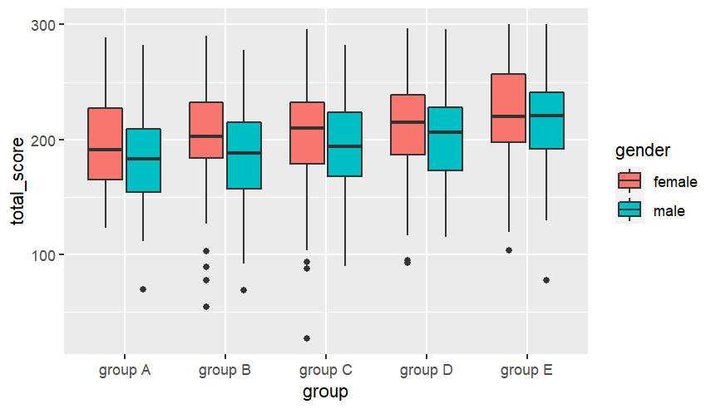
Box Plot to find minimum, maximum, median, Q1 and Q3 value of a group and filtered for gender

